**Archery Madness**GDD

**Overview**

**Product Details**

* *Players*
  + *Single player*
* *Genre*
  + *First Person Casual*
* *Platform*
  + *PC*
* *Outlets*
  + *Steam/Oculus store*

**Summary**

An archery sideshow game based around a carnival; the player can choose from a variety of different arrows to knockout unique targets with different elements.

The player will come up to the table, and they will see

**Mechanics and Systems**

* Arrow shooting
  + Player arms an arrow and pulls back while holding a button/input to draw and releases the input to shoot.
* Arrow Types
  + 3 arrow types exist, Normal, Hammer and Water
* Arrow Supply
  + Players have a limited supply of arrows based on the phase.
  + The type of is affected by the availability of rare targets
* Feedback
  + Haptic Feedback (as the player pulls on the bow, servos/motors vibrate to indicate the strength of the pull, reaching a limit at the shoulder, where it vibrates at maximum)
  + Haptic Feedback 2: If the player holds the string for too long, the servos/motors vibrate more the longer they take to shoot. After a period, it shoots… automatically
  + Haptic Feedback 3: Once the arrow is shot, the string returns to normal with some vibration on the bow hand.
* Points
  + Very basic incremental point system whereby the first pigeons are 5 points, the next 10 and the last ones are 20 pts.

**Player Progression**

Target Movement and Pacing

* The 1st phase targets will be on rails, they will move back and forth in a linear way.
* The 2nd phase targets will also be moving back and forth at a faster pace (and perhaps also side to side, with a set amount of ‘new’ rare targets.)
* 3rd phase, all targets from the previous phases return, and move at an even faster pace (with new rare targets appearing at random places, possibly including the ceiling)

The Phases will also be progressive in their phases based on

Arrow Display

The table will have a container (Barrel/Quiver) for the arrows, at each phase (occurs when all arrows have been shot) the container is filled with a new set of arrows (an effect occurs, like smoke or the arrows bounce up from the container to show the player that new arrows are available.

* 1st phase start: Plain arrows are seen in a container ready to be used.
* 1st phase end: Container is empty for a short period of time, then new arrows appear which will be Hammer type arrows…
* 2nd phase start: as above at the start but with new arrow types and this will repeat for the 3rd phase.

(The container may also have a symbol with a counter in front of it to indicate the type of arrow and the amount that is left to use)

**Pillars**

**Unique Selling Points**

**Target Market**

The target audience of this product is broad. It consists of people (families and individuals) who might typically attend a circus, fair or exhibition. To ensure current industry safety and age guidelines are met developers are to assume children are aged 13+.

Users must be able to wear the desired platform (Oculus Go headset / Google cardboard) and must be able to use any auxiliary hardware to interact with the product (eg Oculus Go controller or Google cardboard, virtual menus).

**Persona**

**Game Loops**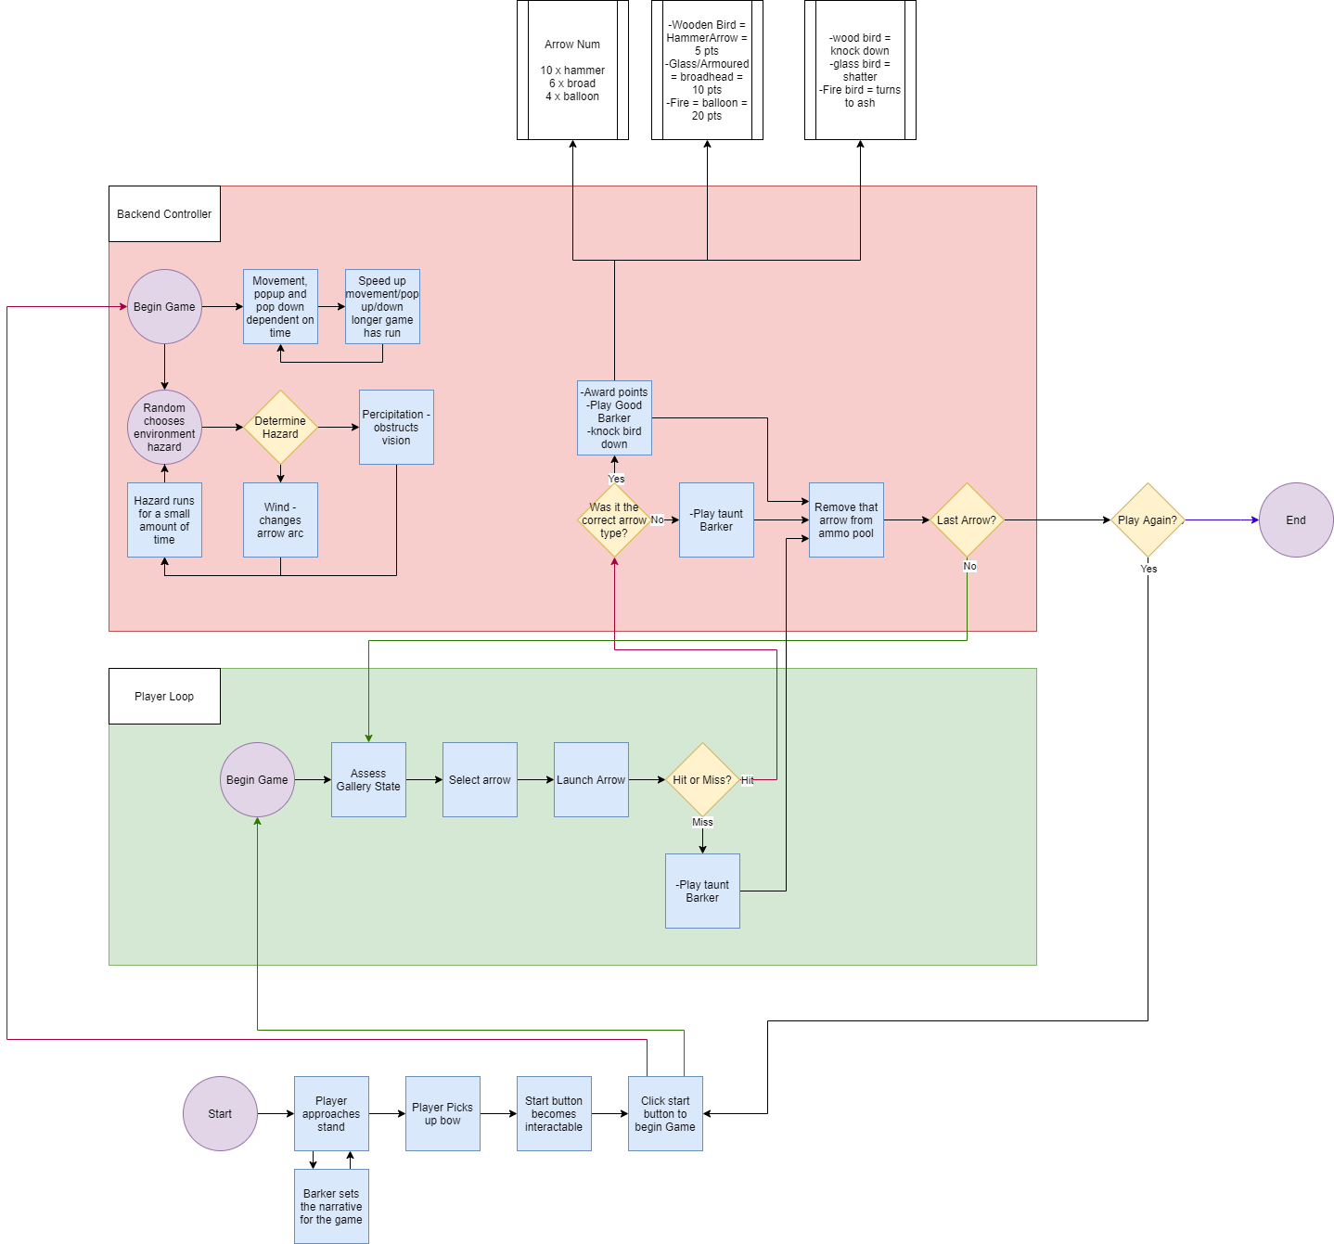

**Controls**

TBD – Must research VR headset we will be using for the possible use of controls.

* It will be around the players hand movements as if they were firing an actual bow to add authenticity and feel to the game, as well as use full advantage of VR capabilities.
* Player movement is limited to being locked at the table or firing area, they will be able to look around.
* Can use controls to draw the bow and fire with the buttons available at the hand controls

**Key Characters**

* Player
  + Player is a visitor to the carnival games and is keen to test out their archery skills against changing targets.
* Barker
  + Essentially an announcer of the players progress or fails, will at times antagonise the player if they miss or chose the wrong arrow.
  + Will encourage the player if the player hits and succeeds.
  + Adds character and theme to the carnival feel of the game.

**Level Design**

TBD – The level is one area in which targets, pacing and access to arrows change after certain conditions have been met (arrows have run out)

**Themes and Story**

* Theme is carnival, bright colours, excitable noises, joy, fun and wonderous
* The story is the player wants to play a game of archery and try out different arrows against different types of targets

**Art Style**

* Art Style

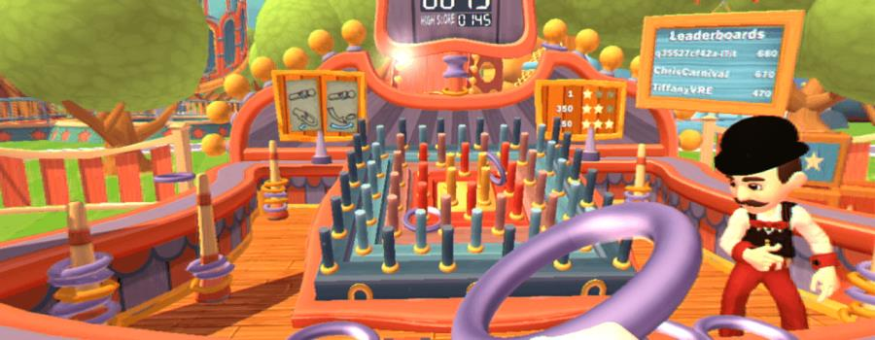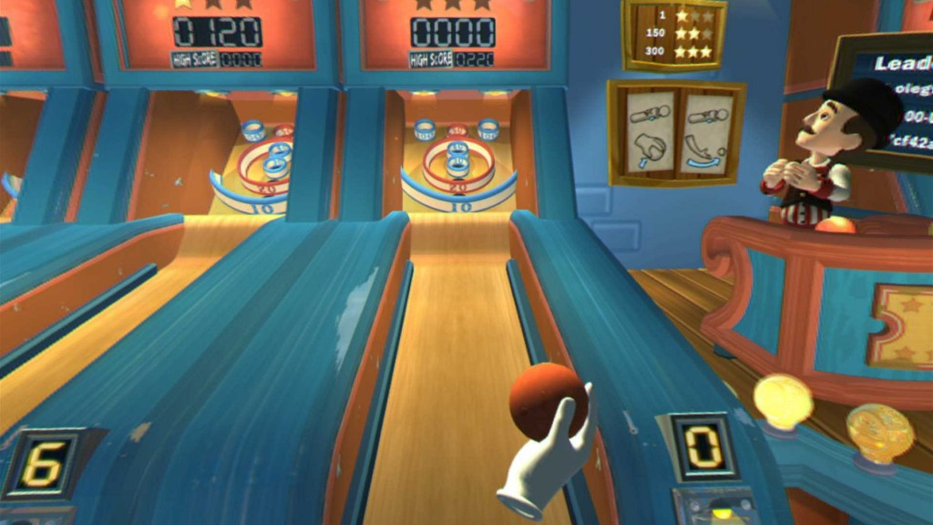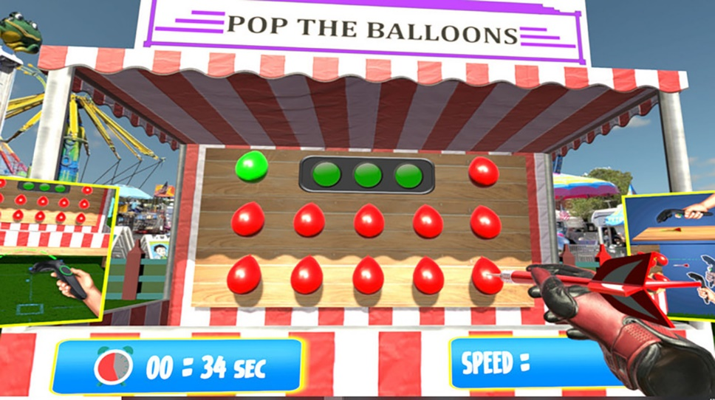

**Aesthetic**

* Arrow Types

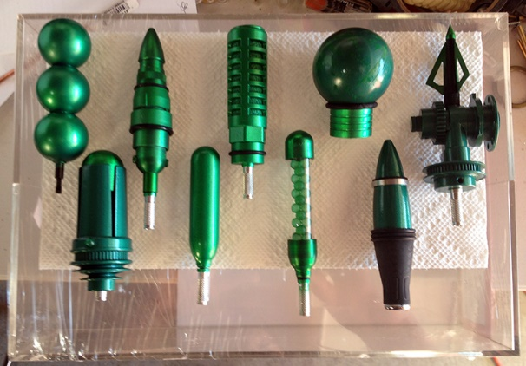

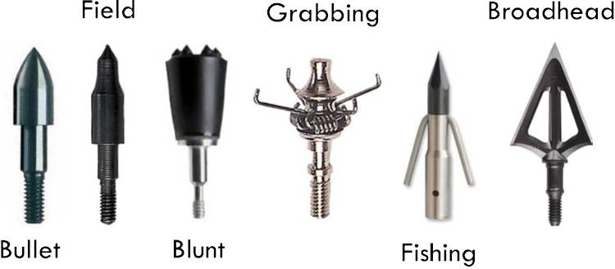

* Bow

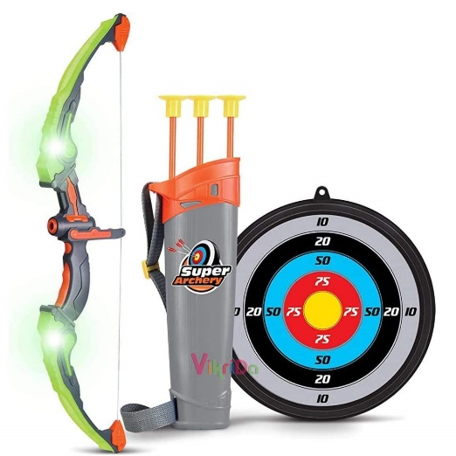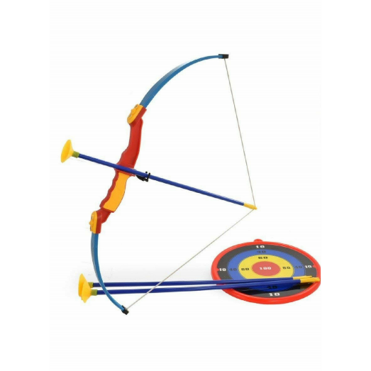

* Targets and Tracks

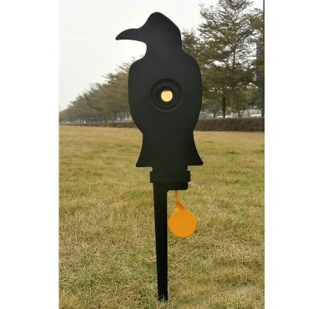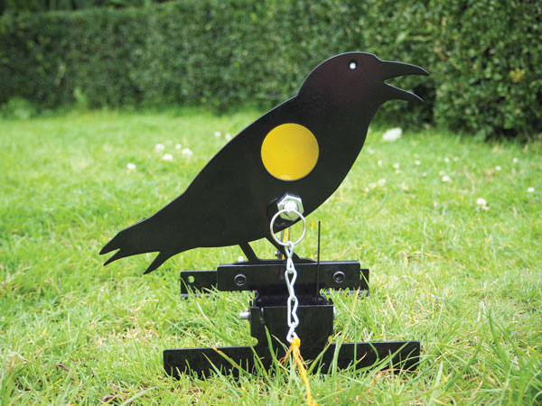

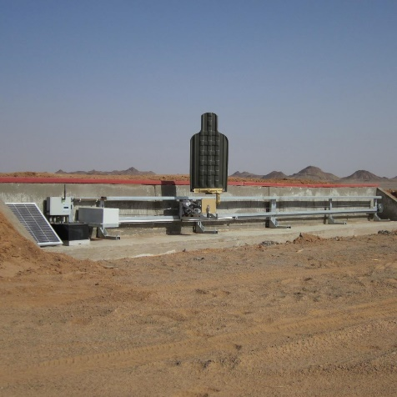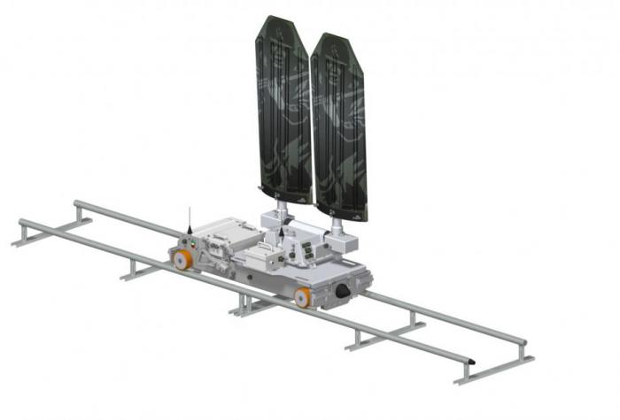

* Arrow

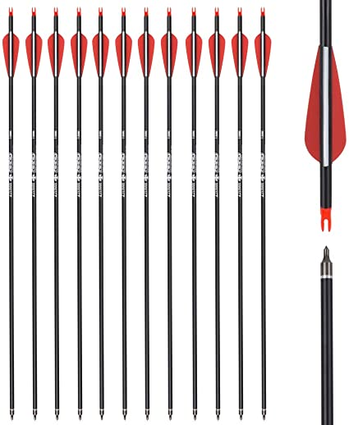

**Colour Palette**





**Sound**

* Voice Over
  + Barker
* Music
  + Carnival/Circus style music